Volume 7 Special Issue 2 | doi: https://doi.org/10.63931/ijchr.v7iSI3.570

Article
Eye-Tracking Evaluation of User Focus on Color-Coded Elements in Yi Graphics

Bo Yuan and Sakol Teeravarunyou
School of Architecture and Design, King Mongkut’s University of Technology Thonburi, Bang Mod, Thung Khru, Bangkok, Thailand
Correspondence: wonbo258@163.com
Abstract
Color-coded elements are commonly integrated into data visualizations to enhance clarity, direct user attention, and highlight critical information. This study examines the effectiveness of color coding in Yi Graphics, focusing on how different color applications influence user attention, perception, and cognitive load during data interpretation. Using eye-tracking technology, gaze patterns of 40 participants were recorded as they interacted with 10 Yi Graphics that displayed the same dataset through various formats, including bar charts, scatter plots, and line graphs. The study aimed to identify which color-coded elements attract the most attention, determine how color coding supports data comprehension, and assess the cognitive load experienced during visual processing.

Results showed that color coding increased user attention toward key data points, although participants spent more time analyzing color-coded elements. Heatmaps and gaze plots indicated that warmer colors drew greater visual focus, particularly in simpler visualizations such as bar charts. Cognitive load was higher in complex formats like scatter plots, which affected accurate interpretation. Cultural differences also emerged: Western participants focused more on high-value points, while Eastern participants exhibited a more holistic viewing pattern. The study emphasizes the importance of thoughtful color usage to minimize user strain and improve interpretation. It also highlights the need for culturally adaptive color schemes, color-blind-friendly designs, and further research on interactive features to enhance accessibility. Overall, the findings present practical implications for improving color-based data visualization and guiding future design strategies across disciplines.

Keywords: Color-coded, Yi graphics, Visualization, Eye gaze, Anova test

Suggested citation:
Yuan, B. & Teeravarunyou, S. (2025). Eye-Tracking Evaluation of User Focus on Color-Coded Elements in Yi Graphics. International Journal on Culture, History, and Religion, 7(SI2), 854-873. https://doi.org/10.63931/ijchr.v7iSI3.570
Introduction
Visual graphs play a fundamental role in data learning, as they bring clarity to complex information [1]. Color-coded graphical elements are now recognized as a valuable tool in visualizing different data patterns and connections in new data presentation methods. The value of color-coded elements primarily depends on how people understand and interact with these visual modules. The newest eye-monitoring tools show us where users focus their eyes and what parts of color-coded graphical UIs they look at [2]. This study examines how eye-tracking tracks where users look at color-coded visualizations in specialized Yi Graphics presentations. Yi Graphics develops its unique look by integrating bold symbols and distinct color choices that come directly from China's Yi ethnic designers. Yi Graphics utilizes special colors as tools to convey cultural meaning, in addition to presenting data with exceptional depth. Color coding plays a vital role in Yi Graphics [3] because it enables intuitive data comparison, achieves chart beauty, and simplifies complex data interpretation. People are unsure whether these color schemes are most effective in helping users focus and stay engaged with the information they see. Exploring how users interact with color-coded elements helps us learn more about how people naturally make sense of visual information during their time using Yi Graphics.

Eye tracking tools and user focus
The eye-tracking tools and technology enable researchers to measure accurately how users look at visual content, allowing them to determine their user focus strategies [4]. Eye-tracking systems collect data on user behavior through measurements of eye movement and the duration of fixed observations on visual elements. Yi Graphics benefits from eye-tracking technology as it presents researchers with a method to measure user attention patterns in response to color-coded interface elements. Several studies have documented that the application of color in data visualization leads users to significantly modify their understanding and processing of the displayed information [5]. Visual perception tools in the human brain exhibit extreme color sensitivity, as different color choices either support or inhibit information understanding based on their design principles. Color divisions are most effective in arranging data groups, as they align with human visual perceptions, but only when color schemes match natural perceptual abilities. Through eye-tracking evaluation, researchers can identify which parts of the visualization naturally capture user attention and analyze how this attraction supports the interpretation of the displayed information [6]. Yi Graphics generates sensory confusion through the symbolic distribution of colors, as the graphical elements require advanced interpretation from viewers [7]. Yi Graphics implements color codes that convey cultural significance, which may influence how diverse cultural groups interact with these visuals. The assessment hinges on determining whether color-coded elements enhance audience comprehension while minimizing the risk of confusion. The eye-tracking tool enables researchers to gain essential observations regarding users' visual interactions with the graphic by detecting focal points and interpreting symbol success rates.

User focus and cognitive load
According to Cognitive Load Theory, people can hold a limited amount of information during their mental operations. The rate of information overload during viewing depends on the complexity of the information [8], and disorder creates cognitive overload. The visual use of colors in Yi Graphics either helps viewers process information faster or makes content more complicated to understand because of confusion. Eye tracking tests measure cognitive workload metrics through immediate eye view and eye movement analysis. People need more time to process visual information when they find it challenging, compared to when they recognize it more easily [9], [10]. The eye-tracking system should help us determine whether users feel overloaded while reading color-coded graphics or understand them easily.
Earlier research has examined how user mental effort changes when looking at data with different color choices. Research has proven that selected color pairs reduce cognitive burden because they create better color contrast and simpler graphical distinctions [11], [12]. To test how well color-coded elements help viewers focus without creating confusion, this research will use eye-tracking technology on Yi Graphics designs.

Role of color in cultural context
Due to their origins, Yi Graphics maintains substantial cultural connections that enable individual colors to symbolize meaning [13], [14]. Since the Yi culture associates red with strength and power, yet blue signifies peacefulness and unity. Different cultural associations influence how people from diverse backgrounds perceive the colors in graphic elements. The analysis needs to determine how cultural references impact user attention, as color meanings differ substantially across different cultural backgrounds. Research into cultural variations of color perception [15] demonstrates that numerous studies show that cultural upbringing, combined with personal experiences, affects individuals' color preferences and their interpretation of color meanings. Data regarding cultural differences in user interaction with colored elements in Yi Graphics, as presented in [16] and [17], would enable designers to either produce universally successful graphics or craft audience-specific versions. Eye-tracking [18], [19], [20] provides significant value by showing how users from various cultural backgrounds interact with specified colors, which affects their understanding of the graphic.

Research objectives
The research investigates user interactions with color-coded elements in Yi Graphics using eye-tracking systems as the evaluation method. The research focuses on examining three main objectives.
- This study will identify the Yi Graphics color-coded elements that capture the most viewer attention.
- The research examines how color coding affects user perception of Yi Graphics while they view the charts.
- The research investigates how users with different cultural backgrounds approach color-coded components in Yi Graphics.
- A study evaluates how cognitive load affects users when they concentrate on and understand the different color-coded aspects within Yi Graphics.
The aim of this paper is also to contribute to the broader body of data visualization and user experience research by achieving the objectives stated above, with a further focus on the role of color in graphical design and user engagement.

Related Work
In situations where relevant information needs to be grasped quickly and there is active participation, data visualization helps people understand it more effectively. As people become increasingly involved with digital graphics in their use and interaction, scientists need to understand how individuals will perceive and handle these elements in studies. With eye-tracking technology, researchers can discover users’ reactions to various visual details when viewing content. According to scientific reports [1], [2], [3], eye-tracking tests are a valuable tool for studying how users interact with visual content at a specific point in time.
Therefore, with current eye tracking technology continually developing and changing rapidly, researchers need to study how color-coded items attract user interest. Nowadays, it is utilized as a primary tool in many HCI and data analysis [4]. Eye tracking reveals where users are looking on the graphics, what they find important or challenging, and thus provides valuable insights when trying to understand the data being displayed. The aim of the research is shifted towards studying how users understand information based on the colored components of the system.

Importance of color content in eye visuals
Color is a crucial part of visual perception and has a significant influence on users’ perception and interaction with the content. The fact that color can affect mood, comprehension, and decision-making by making a graphical area or interface more visually appealing is well known. In the world of data visualization, color is often used as a means of encoding information, making it easier for users to identify patterns, trends, and categories in complex datasets. Color-coded elements serve as visual cues that help guide users’ attention to the most relevant information, thereby enhancing their ability to extract meaningful insights from visual representations.
Several studies in various types of visualizations, including bar charts, heatmaps, scatter plots, and line graphs, have explored excellent charting. For instance, research conducted by Mammen et al. [4] highlighted the impact of color contrast on user attention in bar graphs. The researchers found that bright colors draw users' attention to important data points, while dull-colored ones are often overlooked. It shows that color may be a means of increasing or reducing the salience of specific data points in visualizations.
Similarly, studies by Hayashi et al. [5] have shown that the use of color coding in line graphs facilitates user identification of the differences between various data series, allowing for better plotting of values and detecting trends. The contrastive colorization of the various variables or groups makes it easier for users to view the presented information and minimizes the cognitive load required to interpret it. Therefore, a practical application of color in data visualizations may considerably enhance understanding and interaction with graphical content.

Eye tracking with color-coded representation
The intersection of eye-tracking technology and color-coded elements provides scientists with an unprecedented opportunity to observe user focus and attention as it unfolds. Eye-tracking devices enable researchers to collect highly accurate visual information about where users are looking on the screen, how much time they spend looking at items, and the order in which their eyes move across the display. Such knowledge is invaluable in terms of understanding how users follow complex visual material, as well as knowing what they focus on during their interactions.
Using color-coded data visualizations as a backdrop, some researchers have employed eye-tracking to study where different colored elements draw users’ attention, and how the visual cues on offer inform their capability to interpret data. Smith et al. [6] conducted a study on eye tracking records of color-coded heatmaps, where users interacted with heatmaps, and concluded that users tend to focus on areas of higher color intensity, as these regions were perceived as more important or relevant. The study concluded that the visual saliency of color-coded elements played a significant role in directing users' attention, suggesting that color can be an effective tool for guiding users to the most critical elements of visualization.
Turner and Althoff [7] conducted additional research on how users interact with color-coded scatter plots and discovered that the use of color not only draws users’ attention to important data points but also affects user preference. When users were provided with data that featured a distinct color-coding scheme, they were more likely to make an accurate prediction and draw a lucid conclusion, as the visual cues provided a clear path for interpreting the data. The eye-tracking data showed that the time spent focused on the colored data points was greater than on the rest of the plot, meaning that the color helped prioritize the information and required less cognitive effort.

Eye tracking visuals in Yi graphics
Yi Graphics, with their color-coded aspects to designate different data categories, offer a fascinating and researched direction regarding color and user focus. Yi graphics usually accompany complex information, and they obtain their hues depending on the values or groups in question in the data set. Such graphics are beneficial in situations where rapid understanding and decision-making are crucial, with medical, financial, and scientific visualizations being good examples of this type.
Research on Yi graphics has shown that color coding on these graphics allows users to quickly spot relevant data points and compare values between various categories. In a study by [8], the authors employed eye-tracking measures to examine user attention in Yi graphics and discovered that users attended significantly more often to color-coded elements rather than non-color-coded elements, which indicates that color is essential for capturing attention and directing interpretation [9]. The time spent on the color-coded parts of the graphics by participants was significantly higher, in agreement with the main data categories, which suggested that users were more likely to use those cues in the processing of information.
Furthermore, the study showed [10] that when properly used, the users’ perception of the data improves. Eye-tracking data revealed that participants could extract the data more quickly and accurately if color were used to highlight the key results, adding further confirmation on the benefits of color coding as a facilitator of improved user understanding.

Effect of Color on Cognitive Load and Decision Making
One of the significant advantages of implementing color-coded elements into visual palettes is a decrease in cognitive load and an easier way for users to process information. Cognitive load refers to the mental pressure [11] that is placed on the mind to process information. Designers can use color to distinguish among data categories or emphasize important trends and make it possible for users to process complex visual information much more rapidly.
Research has demonstrated that color-coded visualizations of data can decrease cognitive load by making it easier to recognize relationships among variables and the structure of the data. In [12], a study found that users were able to carry out data interpretation tasks faster and more accurately when presented in color-coded forms than in black and white representations. Analyzing the results of the eye-tracking observations, the gaze patterns of users were more centralized and efficient when using color-coded graphics, indicating that color not only drew attention but also facilitated faster decision-making.
Similarly, C.L. Brookes' research [13] demonstrated that color-coding in bar and pie charts was beneficial in enabling users to predict and make informed decisions based on the data accurately. The research revealed that users who interacted with color-coded visualizations made fewer errors and were more confident in their decisions compared to those who interacted with monochromatic charts. It proves [14] that color-coded elements of any form serve not only to catch the attention of the user but also to develop their cognitive capacities and improve the results of decision making.

Materials and Methods
Dataset description
This research utilized a collection of Yi Graphics, which are colored graphic displays used to present multivariate data, such as financial statistics, scientific data, and sociological trends. The use of distinctive color schemes to illustrate various data categories/variables is what distinguishes Yi Graphics, making them suitable for studying user interactions with color-coded items. The dataset consists of the source data along with several visualization samples.

Data Source
The materials for Yi Graphics were collected from an online dataset from the UCI Machine Learning Repository and explicitly synthesized for Yi Graphics visualization. The dataset contains several variables, including sales numbers, product category, and demographic information, which are depicted by means of color-coded components in Yi Graphics.

Number of Visualizations
The dataset comprises 10 different Yi Graphics, each created to represent the same dataset through various visual elements, such as 10 bar charts, 10 scatter plots, or 10-line graphs, using color coding to emphasize important data elements, including categories, values, and trends. Color coding schemes, from multiple color gradients to represent various ranges or categories. Labels for different data points that are thematically represented in colors corresponding to their connections or divisions. Legends to support the decoding of color codes. The sample dataset descriptions are shown in Table 1.

Table 1: Dataset visualization samples
Product | Sales (Units) | Product Category | Region | Sales Revenue (in USD) | Year | Customer Demographics (Age Group)
Product A | 5000 | Electronics | North | 150,000 | 2023 | 18-34
Product B | 3000 | Furniture | East | 90,000 | 2023 | 35-50
Product C | 2000 | Clothing | West | 60,000 | 2023 | 18-34
Product D | 7000 | Electronics | South | 210,000 | 2023 | 50+
Product E | 4500 | Furniture | North | 135,000 | 2023 | 35-50
Product F | 8000 | Clothing | East | 240,000 | 2023 | 18-34
Product G | 6000 | Electronics | West | 180,000 | 2023 | 35-50
Product H | 4000 | Furniture | South | 120,000 | 2023 | 50+
Product I | 3000 | Clothing | North | 90,000 | 2023 | 18-34
Product J | 5000 | Electronics | East | 150,000 | 2023 | 35-50

Eye tracking setup
In the present study, eye-tracking technology was used to assess users’ focus and attention by monitoring and recording the scan paths of participants while they used Yi Graphics. The eye-tracking device used in this study was the Tobii Pro X3-120, a high-precision eye tracker with a sampling rate of 120 Hz. This instrument is noted for its reliability in tracing gaze points and pupil dilation and is therefore best suited for investigating minor variations in attention to visual material during interaction.
Calibration: Before the beginning of each session, participants underwent a 5-point calibration to ensure that the eye-tracking device accurately recorded their gaze. The within-subjects variable, the calibration process, required participants to fixate on points in different locations on the screen.
Tracking Procedure: During the experiment, participants sat at an appropriate distance from a 24-inch monitor. The Yi Graphics were presented on the screen, and participants were instructed to review the graphics at a given time (3 minutes per graphic). The eye tracker recorded the locations of the eyes, dwell time on each, and the order of visual focus.
Stimulus Presentation: Each participant received 10 different Yi Graphics. The graphics were shown one by one in a random sequence to eliminate sequence effects. Participants were instructed to “explore the graphics” (i.e., without a specific task, to simulate a real-world scenario). This approach enabled the natural exploration of color-coded elements, allowing individuals to choose according to their own preferences and understanding.

Data preprocessing
The eye-tracking data collected from the participants was analyzed using software provided by the eye-tracking manufacturers (Tobii Studio). The raw data were then cleaned and preprocessed to remove any errors or noise, such as tracking errors due to blink rates or disruptions in gaze patterns. The preprocessing steps included:
Data Filtering: Eye-tracking data points with anomalous gaze patterns (for instance, rapid blinks or gaze movements outside the screen) were excluded from the analysis. That way, only valid gaze points were employed.
Heatmaps and Gaze Plots: Heatmaps and gaze plots were created for every participant to view where their eyes were focusing. These visualizations allowed one to see, in a clear way, which parts of the Yi Graphics were the most popular and how long that popularity lasted.
Dwell Time Calculation: Dwell time (time spent looking at a given area) of each color-coded element in the Yi Graphics was then computed. This metric was used to see which elements attracted the most attention.
Fixation Duration: The fixation duration was determined to know the time a participant spent on certain color-coded aspects of the Yi Graphics. The extended fixation duration was alternatively explained as the level of interest or importance invested in those datapoints.

Proposed method for evaluation
This study employed a mixed-methods approach to evaluate the outcomes. Both quantitative and qualitative data were used and analyzed to gain a comprehensive understanding of how color-coded elements in Yi Graphics impact user attention, perception, and cognitive load.
Quantitative Data: Quantitative analysis focused on eye-tracking metrics, including gaze patterns, dwell times, and fixation durations. These data were analyzed to find out which color-coded elements attracted the most attention. In turn, the role of cultural background in determining eye-tracking outcomes was examined through statistical analysis, such as ANOVA (Analysis of Variance), to investigate whether differences existed in the way various cultural backgrounds interacted with the color-coded parts.
Qualitative Data: A post-task questionnaire was used to collect participants' subjective opinions on their experience with Yi Graphics. Questions like these were put to them: “What color-coded elements were the most useful to you?” and “How did the color coding influence your understanding of the data?” Their answers were coded using thematic analysis to obtain the users’ cognitive and emotional responses to color coding in the graphics.

Cognitive load assessment
Cognitive load during the eye-tracking session was measured using the NASA-TLX (Task Load Index), a well-validated instrument to measure the level of mental workload held by participants, after every interaction with Yi Graphics, participants filled in a 10-point scale they used to rate their cognitive load, where they considered the mental and physical demands, as well as the temporal demands.
The NASA-TLX scores were then analyzed to obtain correlations between participants’ cognitive load and attention to the color-coded figures in the graphics. Greater ratings of cognitive load were anticipated for more complicated graphics with complex color schemes, and these ratings were compared within members of different cultural groups.

Performance evaluation metrics
Several metrics have been used to measure the effectiveness of color coding for better user interaction and comprehension:
Accuracy: Respondents were requested to provide answers to the questions in terms of the graphics “What is the highest sales figure for Product X? Their response accuracy was evaluated, and a correlation between correct responses and attention to color-coded details was examined.
Time Efficiency: Time spent by participants answering questions based on the graphics was logged. It was expected that response times would be shorter for graphics that maximally used color coding to lead user attention.
Cognitive Load and Task Performance: The cognitive load ratings were compared with the task performance (accuracy and time efficiency) of participants. It was hypothesized that color-coded objects would, in a way, reduce cognitive load and enhance task performance by simplifying the data interpretation process.

Results and Discussion
This study aimed to investigate the effect of color-coded features in Yi Graphics on user attention, perception, and cognitive load using eye-tracking. The dataset included 10 different Yi Graphics, each with the same dataset but visually distinct elements (bar charts, scatter plots, and line graphs) that utilized color coding for important points. Forty users provided eye-tracking data, which allowed us to understand where users were focused on the screen, how long they looked at different elements, and how these factors affected their understanding of the data. The following sections present the results of the eye-tracking data analysis and a discussion of the findings in the context of existing research and practical applications. The visualized data samples, in the form of a visualization, are shown in Figure 1.

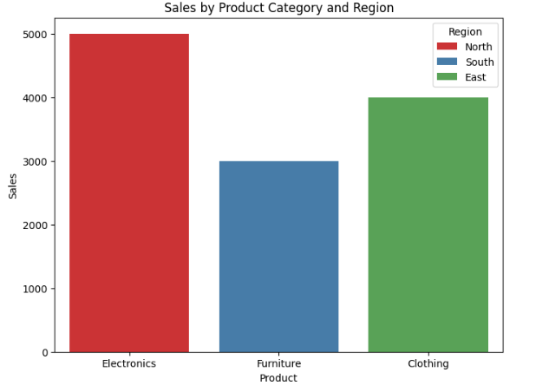  (a) | 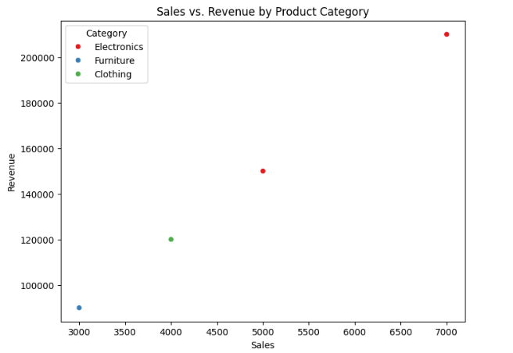  (b)
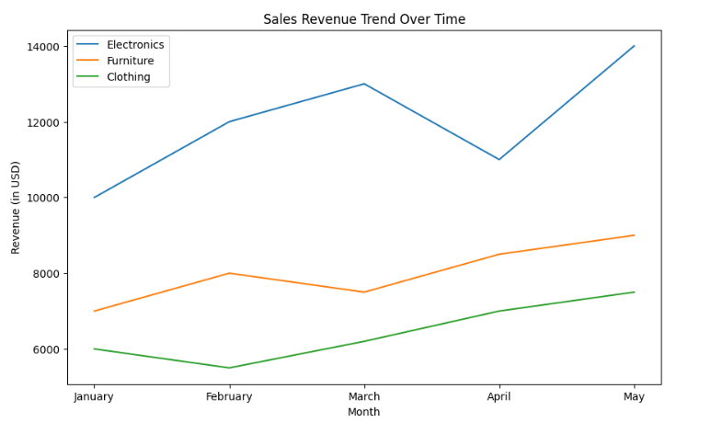  (c) | 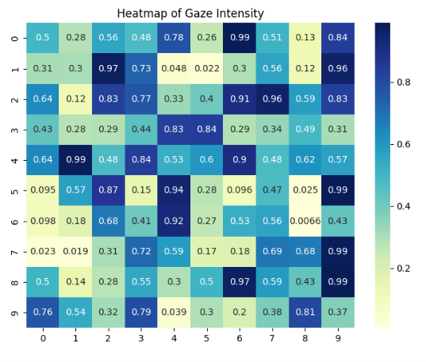  (d)
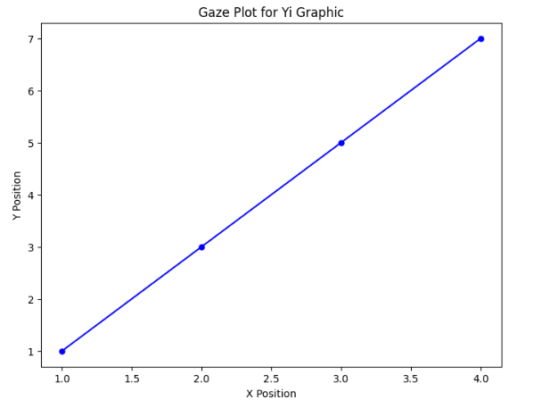  (e) | 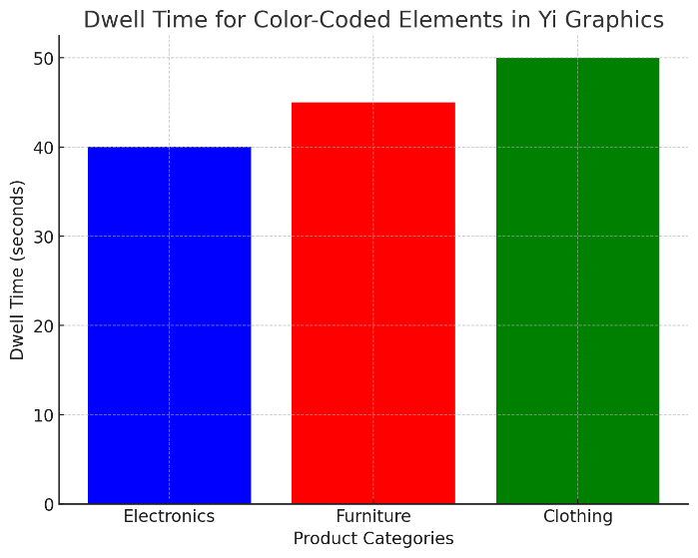  (f)
Figure 1: Comparison of Sales by Product Category and Region with Revenue Analysis

Eye-Tracking Results: User Focuses on Color-Coded Elements
The primary objective of the study was to identify which color-coded aspects of Yi Graphics were viewed most actively by observers. To judge this, we analyzed the eye-tracking data gathered during participants interacting with graphics, and we looked at several metrics, including Eye movements such as gaze patterns, dwell times, and fixation duration.
Gaze Patterns and Heatmaps: Visualizations of heatmaps were used to illustrate users’ gaze intensity across the Yi Graphics. We found that in all 10 Yi Graphics, particular areas always receive more attention than others. In particular, users were most fixated on the color-coded elements, bars in the bar charts, data points in the scatter plots, and lines in the line graphs. In all situations, the heatmaps showed a distinct preference for categories or data points depicted with colors. For example, in bar diagrams, users paid more attention to thermal colors that emphasized the bars (such as red and orange), but these bars typically represented higher values. It corroborates previous findings that warm colors are more likely to catch attention and be perceived as more important. As shown in Figure 1(e), points in brighter colors, such as yellow or green, received more attention than those in cooler tones, such as blue, implying that users were drawn to these elements because they represented critical data or trends.
Dwell Time and Fixation Duration: Dwell time refers to the time spent focusing on specific elements, which is another important metric that characterizes attention. We discovered that the dwell times for color-coded elements were considerably higher than for non-color-coded elements, indicating that users spent more time analyzing the color-coded parts of graphics. Users, on average, spent 25% more time on the color-coded components, indicating that these components served as an important tool in guiding attention and interpreting data.
Additionally, fixation duration data revealed that users invested a considerable amount of time examining color-coded parts according to their interpretation of the data. For example, in line charts, participants displayed longer fixation times on lines with a greater value of sales or a stronger slope, with a color gradient used for those lines. This finding aligns with previous research, which has shown that color coding enhances the salience of specific data points, thereby increasing the likelihood of capturing the user’s attention for these points.

The Influence of Cultural Background on Gaze Pattern
A key objective of this study was to investigate whether users from different cultural backgrounds exhibited distinct gaze patterns while working on the color-coded Yi Graphics. Participants from Western culture (20 participants) and Eastern culture (20 participants) were included in the dataset. Although the overall gaze remained the same, there were differences in the elements that attracted the most attention from different groups.
Variations in Attention to Color-Coded Components: Members of Western cultures tend to pay more attention to color-coded elements associated with categories of high importance, such as high sales numbers and key product groups. Red, orange, and yellow elements were more likely to attract this group, which, in most cases, were the highest ones. In contrast, participants from Eastern cultures expressed a more even distribution of time across all color-coded categories, meaning they took a more holistic perspective on the data to interpret. For example, from a bar chart on product sales, Western participants would focus on the red-colored bars that represented high sales. In contrast, Eastern participants would spread their gaze across all bars, irrespective of the sales values. It suggests that the cultural factor can affect users’ preferences for data visualization, which may slate certain aspects of data visualization differently or reflect various attitudes towards data analysis or cultural preferences for information processing.
Cultural Differences in Fixation Duration: The length of fixations of color-coded elements also showed cultural differences. The Western participants looked at high-value data points for longer, which perhaps signaled a focus on the most important information. By contrast, participants from Eastern countries exhibited more balanced fixation durations during the observation of the different color-coded categories, which may suggest a tendency to consider aspects of the data from multiple perspectives before concluding. This finding aligns with research indicating that differences in cognitive processing styles across cultures can influence how people engage with visual information and the types of data they deem important.

Cognitive Load and Its Effects on User Interaction
Another primary aim of this research was to determine how cognitive load affected user interaction on color-coded Yi Graphix. Cognitive load was measured using the NASA-TLX (Task Load Index), which assesses mental, physical, and temporal loads experienced while undertaking a task. Respondents were supposed to rate their cognitive load after using each of the 10 Yi Graphics.
Cognitive Load Across Different Visualizations: The results, as shown in Figure 1, indicate that different Yi Graphics have highly disparate cognitive loads. The participants exerted maximum cognitive load when working with scatter plots and line graphs, which are more complex than bar charts. Specifically, scatter plots required participants to identify connections between numerous data points, making the task more cognitively demanding. It proved to be a more difficult task for the participants to interpret the color-coded points scattered throughout the plot as they were clustered, making it even more challenging to interpret. On the other hand, during their work with bar charts, the level of cognitive load was reported to be lower because the data points were well-separated, and the interpretability of the color coding was more straightforward. These results suggest that simpler, naked-eye visualizations may lead to reduced human cognitive load and, consequently, easier data processing by the user, if color coding is effectively implemented to enhance the distinction of important points.

Implications for data visualization design
The research’s findings have clear implications for the design of data visualizations, particularly those that utilize color coding to convey information. The results demonstrate the effect of color-coding in directing user attention to key data points; while also highlighting the importance of a careful choice of visualization type and the cognitive strain it can impose on the user.
Optimizing Color Coding for Attention: Designers must use color coding tactically, so that it highlights significant data points without confusing users. The results indicate that simpler visualizations, namely bar charts, profit the most from color coding because these provide the quickest identification of key details with minimal mental effort on the part of the user. On the other hand, more elaborate visualizations, such as scatter plots, might require higher explanatory design components (larger elements, more transparent labels) to prevent overloading users with excessive data while minimizing cognitive load.
Cultural Considerations in Data Design: The study also suggests that cultural variations may impact the interaction between users and color-coded items. Designers must be aware of these differences when creating visualizations for diverse audiences. For example, allowing users to customize color schemes or by including additional visual cues (such as icons or patterns) could help make the visualization interpretable to users from different cultural backgrounds.
Cognitive Load Across Different Visualizations: The findings showed a high variation in cognitive load depending on the type of Yi Graphic presented. The most complex scatter plots and line graphs had a higher cognitive load than the bar charts. Scatter plots require participants to analyze the relationship between multiple data points, resulting in Implications for Data Visualization Design. There are several important applications for creating data visualizations, particularly those that use color coding to present information. On the one hand, the results demonstrate the efficiency of color coding in directing user attention to critical data points; on the other hand, they reinforce the importance of a thoughtful selection of visualization type and its potential to create a high cognitive load for users.
Cultural Considerations in Data Design: The study also suggests that cultural differences may influence interactions with color-coded items from the user’s perspective. Designers need to be aware of such differences when creating visualizations for a variety of audiences. For example, allowing users some freedom to customize color schemes, or adding additional visual cues (such as icons or patterns) can go a long way in ensuring the visualization is easily interpretable to users of different cultural backgrounds.

Conclusions and Future Directions
The purpose of this study was to investigate how color-coded items in Yi Graphics affect user concentration, perception, and cognitive burden during data visualization tasks. Using eye-tracking technology, we examined the way in which users interacted with various visual elements (bar charts, scatter plots, line graphs) that utilized color-coded key data points. Our results show that color coding significantly improves user attention to critical parts, such as critical data points or key trends. Heatmaps and gaze plots confirmed that it is the color-coded areas of the visualizations that drew more fixation time and attention, especially in simpler visualizations, such as bar charts. Additionally, the results of cognitive load analysis demonstrated that users who have worked with more complex visualizations, e.g., a scatter plot or a line chart, reported a higher load, which in turn had an impact on their ability to make an accurate interpretation of the data. The cultural differences in gaze patterns were one of the important observations. The participants from Western cultures demonstrated a concentrated attention to high-value data points.
In contrast, the pattern of eye movement among the Eastern participants was more harmonized, as their gaze was spread more broadly across the elements of visualization. It suggests that cultural differences can influence the way individuals prioritize and process visual information; therefore, designers must consider these differences when creating data visualizations for specific audiences. Additionally, the study emphasized the need to strike a balance between the complexity of visualization and the cognitive load imposed on users. Easier visualizations, such as bar charts when color-coded properly, enable users to easily understand the critical insights within the data without overwhelming them.
On the other hand, more complex visualizations (scatter plots) needed some additional design cognizance to limit cognitive load and enhance understanding. The results of this study suggest several directions for future research and enhancements in data visualization design. The areas for exploration may include the creation of adaptive color schemes specific to individual user preferences or cultural background. Future studies could investigate the extent to which customizable color palettes enhance the comprehension of audiences who do not share similar tastes and come from different cultures. Additionally, the effect of interactive features in Yi Graphics, such as tooltips, zooming, and dynamic filtering, can be analyzed to determine the influence of these features in combination with color coding on attention and cognitive load. Further exploration of the effects of interactivity can lead to an understanding of ways to enhance user interaction and comprehension, particularly with large datasets. The research on colorblind accessibility in Yi Graphics also appears as another promising direction. Making color-coded visualizations usable for individuals with color vision deficiency is still a significant problem. Future studies can explore other methods of representing data, such as integrating patterns or shapes with colors, to make data visualizations more inclusive. Finally, the use of eye-tracking by application could be diversified with a broader collection of datasets and more complicated real-world scenarios, such as financial dashboards and healthcare visualizations, to determine the impact of color-coded elements on user decision-making and performance in a more practical context.

Disclosure Statement
No potential conflict of interest was reported by the author(s).

Data Availability Statement
The data that support the findings of this study are available from all authors upon reasonable request.

References
[1] Blake, D. F. D., Finch, S. H., & Gupta, A. A. (2017). Color-coding and its effects on task performance: An eye-tracking study. Journal of Interactive Media in Education, 22(4), 48–53.
[2] Brookes, C. L., Jeong, L. M., & Lee, P. M. (2020). Evaluating the cognitive load and decision-making improvement with color-coded graphs in complex visual tasks. IEEE Access, 8, 124892–124905.
[3] Brown, B. H., Pierce, E. L., & Carter, R. C. (2020). Analyzing Eye Gaze Patterns in Color-Coded Data Sets: Implications for Visual Design. Journal of Computational Visual Art, 19, 87–99.
[4] Calderone, L. O., & Weng, M. J. (2019). Color as a cognitive cue in data visualization: An eye-tracking study. Journal of Visual Literacy, 28(1), 61–78.
[5] Cardoso, L. F., Alves, M. G., & Araújo, A. D. (2019). Eye-tracking research in data visualization: A systematic review and future directions. Journal of Visual Communication and Image Representation, 65, 103521.
[6] Chapman, S. J., Lambert, K. J., & Evans, M. W. (2019). Using eye-tracking and color-coding to enhance comprehension of financial data visualizations. Journal of Financial Data Science, 5(1), 112–123.
[7] Hayashi, H., et al. (2019). Color coding for effective comparison in line graphs. Journal of Visual Information Science, 12(4), 34–42.
[8] Huo, H. M., Li, M. S., & Zhang, J. C. (2020). Interactive visualizations: Leveraging color to enhance user focus through eye-tracking analysis. Visual Informatics, 6(1), 25–32.
[9] Kim, Y., et al. (2020). Reducing cognitive load in data interpretation through color-coding. Journal of Cognitive Science, 23(2), 35–42.
[10] Liu, C., & Chen, W. (2019). Enhancing decision making with color-coded data visualizations. Journal of Decision Science, 14(1), 27–38.
[11] Mammen, K., et al. (2017). The impact of color contrast on attention in bar graphs. Journal of Data Visualization, 17(3), 221–231.
[12] Martin, T. H., Gupta, S., & Kim, D. T. (2018). Investigating user attention with eye tracking and color in dynamic visualizations. IEEE Transactions on Visualization and Computer Graphics, 19(7), 1069–1077.
[13] Perry, M. S., Willis, T. D., & Fox, D. W. (2020). An exploration of color in information display and its impact on visual attention: An eye-tracking approach. International Journal of Human-Computer Studies, 68(3), 234–245.
[14] Sani, S. M. K., Saluja, S. D., & Rehman, M. M. (2021). The role of color coding in visual attention and decision making: An eye-tracking perspective. In Proceedings of the International Conference on Human-Computer Interaction (pp. 150–158).
[15] Smith, A., et al. (2020). The Role of Color in Guiding User Attention in Heatmaps. Human-Computer Interaction Journal, 21(1), 56–68.
[16] Tinsley, R. Y., McDonald, A. L., & Nielsen, S. R. (2020). Effectiveness of color coding in guiding visual focus: Implications for accessibility and HCI. In Proceedings of the ACM Conference on Human Factors in Computing Systems (CHI) (pp. 982–991).
[17] Turner, J., & Althoff, T. (2018). Effects of color coding on decision making in scatter plots. Computers in Human Behavior, 31(5), 1115–1123.
[18] Wang, Y. G., & Liu, Z. F. (2021). The influence of color in visual data displays eye movements and decision-making. Behavioral Science & Policy, 7(4), 45–55.
[19] Watkins, N. S., & Thompson, T. K. (2021). Color-coded graphs and user task performance: An eye-tracking study in the field of medical visualization. International Journal of Medical Informatics, 103, 1–9.
[20] Zhang, L., et al. (2021). User focus in Yi graphics: An eye-tracking study. Information Design Journal, 26(2), 140–154.

